User Manual

For any help required during the process of using Car Workshop Management system please go through the following instructions.

Contents

Customer Creation 2

Staff Creation 3

Insert Car Part 4

Search Staff 5

Search Car 6

Search Customer 7

Conclusion 9

# Customer Creation

Only Admin and Receptionist can create new customer.

1. First click in Customer Controller

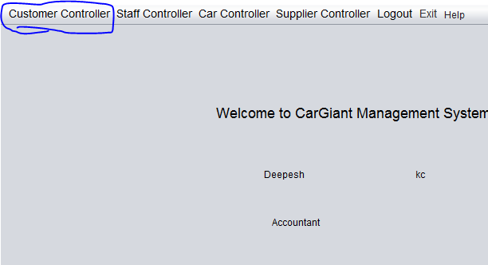

1. Then Fill the form and click submit button and a staff selector panel appears. Then click assign.

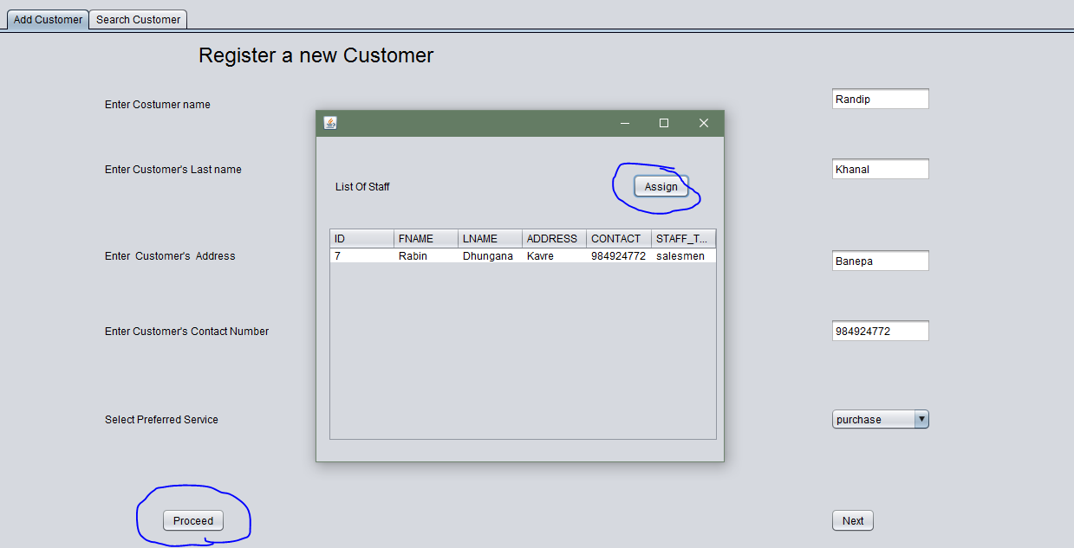

# Staff Creation

1. First click on staff Controller.

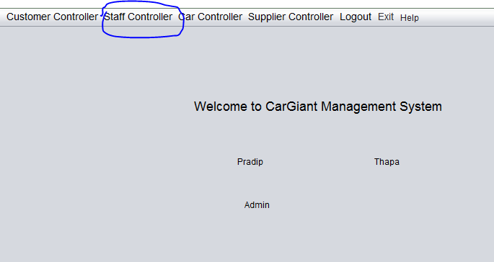

1. Then enter all the credentials and press submit. A success message will appear.
2. 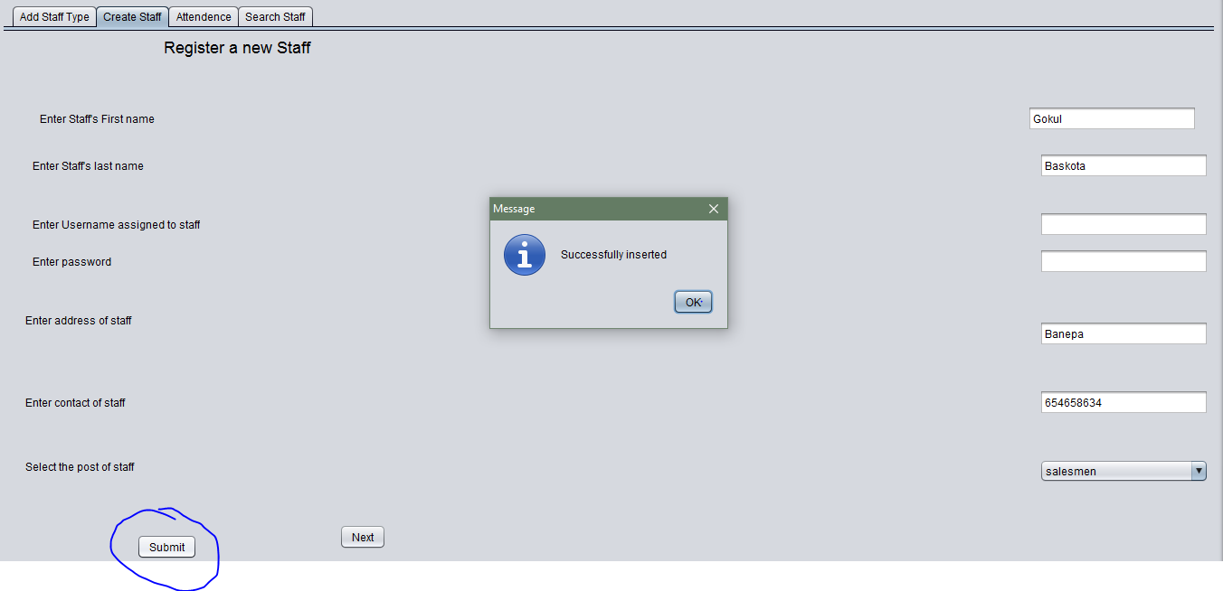

# Insert Car Part

1. Frist click on Car Controller and a form will appear. Fill the form and click add.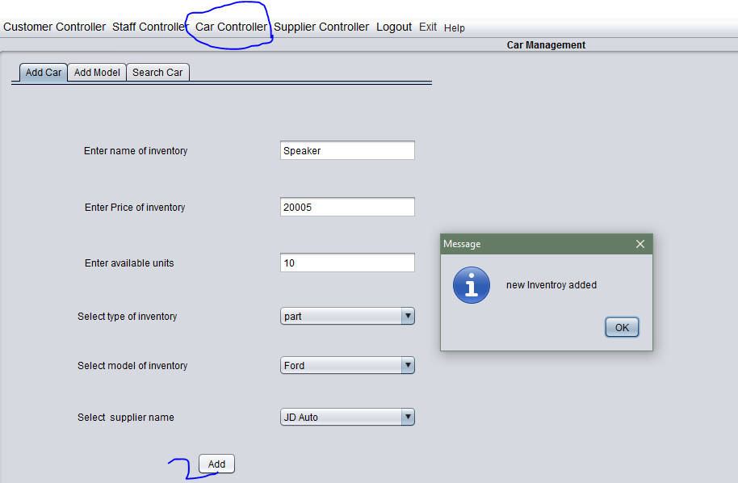

# Search Staff

First click on staff controller and select search tab. Then enter the name of the staff. The information of the staff will appear on table. Then the staff can be updated, deleted and attendance history can be viewed.

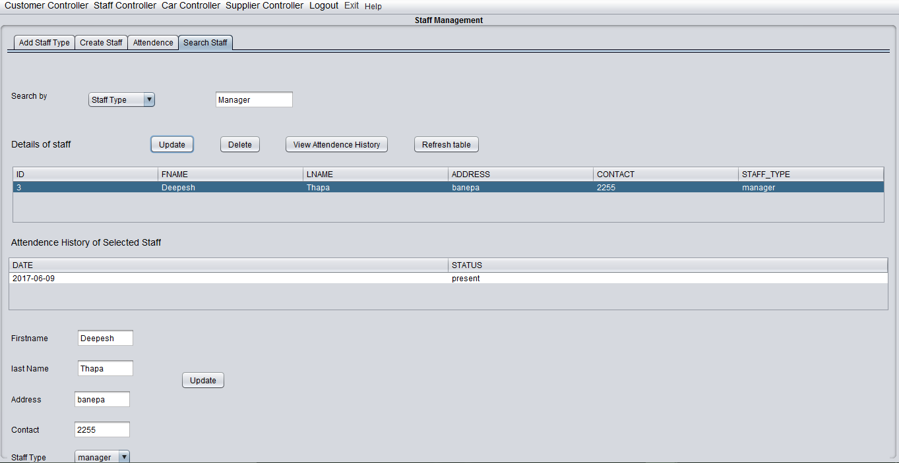

Only admin and manager can update and delete the staff.

# Search Car

First click on the customer controller panel. Then search the car either by model or name. The details of the car will be shown in the table. Then select the particular car to update or delete them.

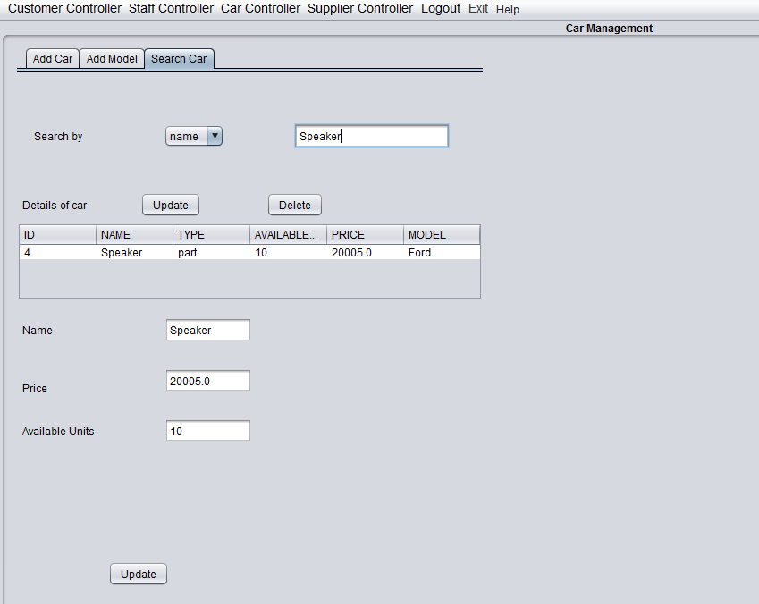

# Search Customer

First click on the customer controller then select the search tab. Then enter the name of customer you want to search. The details of the customer will appear on table.

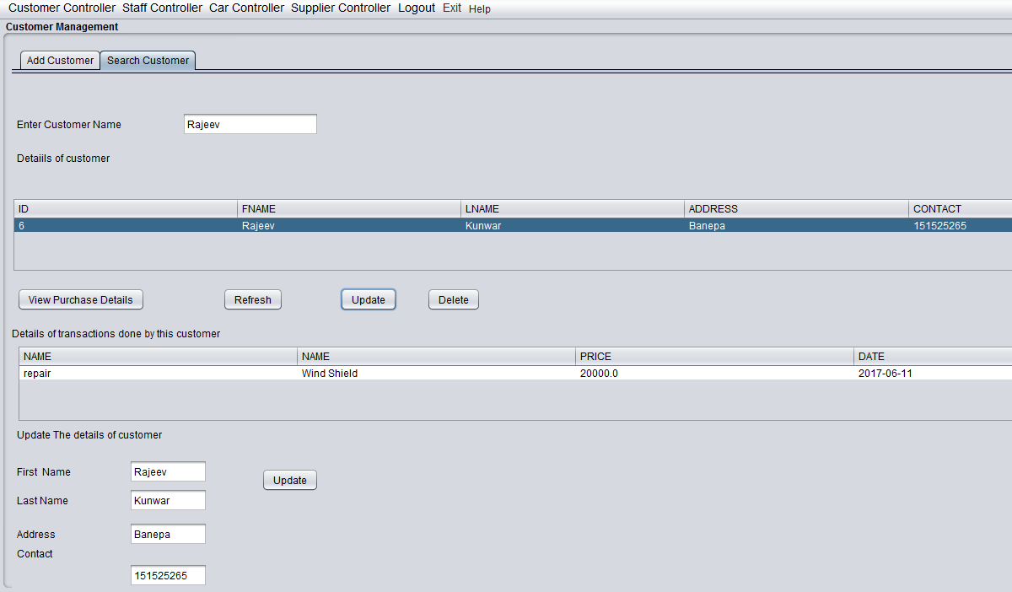

Prepare Salary Statement

Only accountant can prepare salary statement. First select the staff controller and click on prepare salary statement. Then select the name of staff.

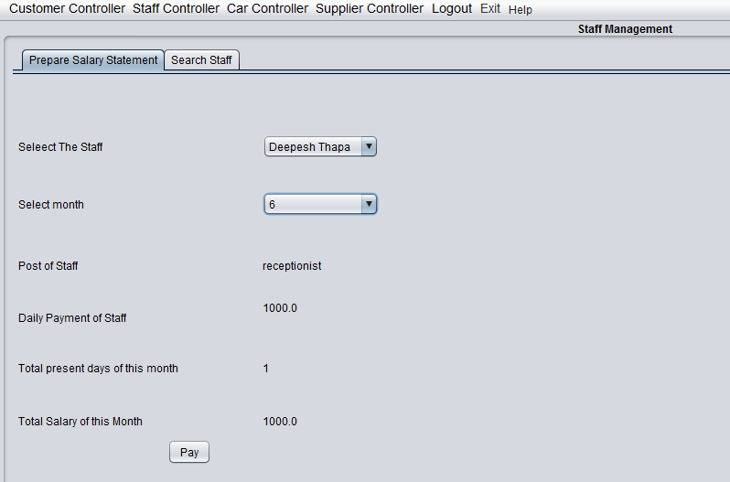

# Conclusion

Hence in this war this car workshop management system can be used in a workshop to increase its productivity.